 

***Explainable Deep Learning (i.e., classification).***

***Ahmed Mohamed Elsaid ,***

Muhammad Yasser Muhammad Ahmed

***, Tarek Ahmed ,***

***Mohamed El-hadi ,***

***Mohamed Nabawy and Ahmed Elsayed Saber***.

***Faculty of computers and Informatics, Zagazig University, Zagazig, 44519, Egypt***

***E-mails:***

[***tarekahmed5578@gmail.com***](mailto:tarekahmed5578@gmail.com)***,***

[***elsheikha941@gmail.com***](mailto:elsheikha941@gmail.com)***,***

[***mhmdyasser1212@gmail.com***](mailto:mhmdyasser1212@gmail.com)***,***

[***ahmedaboelsood1962@gmail.com***](mailto:ahmedaboelsood1962@gmail.com)***,***

[***elhadimohamed112@gmail.com***](mailto:elhadimohamed112@gmail.com)***, and*** [***mohamadnabawy9@gmail.com***](mailto:mohamadnabawy9@gmail.com)

***Correspondence:*** [***ahmedaboelsood1962@gmail.com***](mailto:ahmedaboelsood1962@gmail.com)

***Abstract***

**Coronavirus disease (COVID-19) is an infectious disease caused by a new virus never identified before in humans. This virus causes respiratory disease (for instance, flu) with symptoms such as cough, fever and, in severe cases, pneumonia. The test to detect the presence of this virus in humans is performed on sputum or blood samples and the outcome is generally available within a few hours or, at most, days.**

**Analysing biomedical imaging the patient shows signs of pneumonia. In this paper, with the aim of providing a fully automatic and faster diagnosis, we propose the adoption of deep learning for COVID-19 detection from X-rays.**

**In particular, we propose an approach composed by three phases: the first one to detect if in a chest X-ray there is the presence of a pneumonia. The second one to discern between COVID-19 and pneumonia.**

**The last step is aimed to localize the areas in the X-ray symptomatic of the COVID-19 presence .**

**Due to the spread of the Coronavirus and its mutated strains, this project, which is the first project for patients and X-rays, to classify the triple between a healthy lung and one infected with the Coronavirus before causing pneumonia and then pneumonia.**

**Hence the idea of ​​this project began, and it is based on the creation of a CNN model, which helps us to diagnose the deformity in the lungs through X-rays, and then determine the infection present in it, whether it is Covid 19 or pneumonia, and in the absence of an infection or Distortion, The model indicates that it is not infected, and due to the lack of legislation for the use of artificial intelligence in sensitive areas such as health and medical fields, we have used explainable deep learning, which works to abolish the concept of the black box, which is the definition of deep learning. We prepared the model and using some techniques we**

**linked it to the Apple iOS application and webpage to be easy to use by doctors as well as patients**

**According to our model, we managed to predict if the X-ray that we had is Covid- 19, Pneumonia, or Normal, and our model display the result.**

**Our model has reached 95% accuracy and that was the best we have done yet because of the data set that we have given to us .**

***Introduction***

**The COVID-19 presentation, which started on December 31, 2019, when reports of pneumonia with unclear origins were made in Wuhan, Hubei province of China, has grown into a pandemic. SARS-CoV-2 is the name of both the virus and the sickness, COVID-19. In 30 days, this novel virus spread from Wuhan to most of China. By the fifth of April 2020, there were over 300,000 instances in the United States of America, where the first seven cases were initially reported on January 20, 2020. The majority of corona viruses afflict animals, but because they are quixotic, they can potentially spread to people.**

**Acute severe respiratory syndrome Both the Middle East respiratory syndrome Corona virus and the SARS Corona virus have been responsible for serious respiratory illness and human death.  
 Fever, coughing, sore throat, headaches, weariness, muscle soreness, and shortness of breath are among the usual clinical symptoms of COVID-19. Real-time reverse transcription-polymerase chain reaction testing is now the most popular test method for COVID-19 diagnosis (RT-PCR). The early identification and treatment of this condition depend heavily on chest radio logical imaging techniques including computed tomography (CT) and X-rays.**

**Even when negative findings are obtained due to the low RT-PCR sensitivity of 60–70%, symptoms might still be found by looking at patients' radio logical imaging.**

**According to the claim made in, RT-PRC and CT can be used as screening tools to identify COVID-19 pneumonia. After the onset of symptoms, CT findings are monitored over an extended period of time , and patients often have a normal CT during the first 0–2 days. Ten days after the onset of symptoms, the most substantial lung damage was found in a study on lung CT of patients who had survived COVID-19 pneumonia.  
 Doctors are advised to only make a diagnosis based on clinical and chest CT results because Chinese clinical center at the beginning of the pandemic had limited test kits, which are also creating a high percentage of false-negative results. In nations like Turkey, where there were few test kits available at the start of the epidemic, CT is frequently employed for COVID-19 identification.**

**According to researchers, integrating laboratory findings with clinical imaging aspects may aid in the early diagnosis of COVID-19. For diagnosis, radio logic images from COVID-19 instances have valuable information.  
Changes in chest X-ray and CT images have been seen in certain investigations before the onset of COVID-19 symptoms. Researchers have made important discoveries through imaging analyses of COVID-19.**

**Most people who get COVID-19 have mild or moderate symptoms like coughing, a fever, and shortness of breath. But some who catch COVID-19 get severe pneumonia in both lungs. COVID-19 pneumonia is a serious illness that can be deadly. What Is Pneumonia? Pneumonia is a lung infection that causes inflammation in the tiny air sacs inside your lungs. They may fill up with so much fluid and pus that it’s hard to breathe. You may have severe shortness of breath, a cough, a fever, chest pain, chills, or fatigue. Your doctor might recommend cough medicine and pain relievers that reduce fever. In the most serious cases, you may need to go to the hospital for help breathing with a machine called a ventilator. You can get pneumonia as a complication of viral infections such as COVID-19 or the flu, or even a common cold. But bacteria, fungi, and other microorganisms can also cause it.**

**With the unraveling of the relationship between immune responses and COVID-19, immune characteristics are now being recognized as potential biomarkers for disease progression as well as potential therapeutic targets for COVID-19. In this review, we summarize the immune characteristics of COVID-19 and discuss the potential mechanisms of SARS-CoV-2-induced immune changes, their effect on disease outcomes, and their implications for potential COVID-19 treatments.**

**How Many People With COVID-19 Will Get Pneumonia?**

**About 15% of COVID-19 cases are severe. That means they may need to be treated with oxygen in a hospital. About 5% of people have critical infections and need a ventilator. People who get pneumonia may also have a condition called acute respiratory distress syndrome (ARDS). It’s a disease that comes on quickly and causes breathing problems. COVID-19 can cause severe inflammation in your lungs. It damages the cells and tissue that line the air sacs in your lungs.**

**These sacs are where the oxygen you breathe is processed and delivered to your blood. The damage causes tissue to break off and clog your lungs. The walls of the sacs can thicken, making it very** **hard for you to breathe.**

**Our study proved the feasibility of adopting a deep learning approach to help clinicians discover patients with COVID-19 through X-ray images. Depending on deep learning's high performance in the task of detecting people with Covid-19, the proposed prediction model is now able to rapidly identify the patient. In this paper, we used a CNN algorithm [8] that is trained on a set of X-ray images to determine whether a person is suspected of being infected with Covid-19 virus or not. The Chest X-ray images dataset which contains about 6432 X-ray images was collected from the Kaggle website .**

**The rest of the paper reviews some related works. Then, Installation of CNN algorithm used in this study is described. After that, the methodology is explained.**

***Literature Survey***

**Knowledge extraction from medical data can help in detecting diseases in the early stages . Many researchers worked on medical images using CNN algorithm. Gulshan et al. developed a deep learning algorithm by using large datasets to exceed the performance of medical professionals, in a wide set of medical imaging tasks, with the aim of automatically detecting diabetic retinopathy and diabetic macular edema in retinal funds images where a definite type of an improved neural network to image classification which is called deep convolutional neural.**

**In this research, we seek to prove the feasibility of applying a deep learning algorithm in early detection of infection with the Coronavirus and to determine whether using the algorithm could lead to the development of an accurate computer-based method to help doctors to identify COVID-19 patients by using x-ray images.**

***Related Works***

1. **Apostolopoulos and Mpesiana used pre-trained models using convolutional neural networks with a dataset of 1,427 X-ray images, (700) from patients with pneumonia, (224) COVID-19 disease, and 504 normal; The purpose of the study is to evaluate the performance of convolutional neural network architectures proposed for medical image classification. The results of the Deep Learning with X-ray imaging to Covid-19 disease were The best accuracy (98.66%). The aim of the study is to evaluate the performance of the proposed convolutional neural network architectures for classifying medical images. Deep learning results using X-ray imaging of Covid-19 showed better accuracy (98.66%), while in this paper, the CNN was constructed and trained from scratch, rather than using a pre- trained model for applying transfer learning.**
2. **Cohen et al. provided a neural network model for predicting land measuring the severity of pneumonia in general and covid-19 chest X ray images for use in escalation and de-escalation in care and to monitor the effectiveness of treatment used in the intensive care unit.**
3. **CheXNet is a 121-layer condensed model trained in the ChestXray14 dataset containing 100.000 front chest images. Training the model was based on categorizing X-ray images into 14 different categories of chest diseases. As a result of CheXNet training on a more specific dataset, it became more efficient to classify x-rays. Fig. 1 shows the CheXNet building strücture, which consists of an input shape 224 * 224 * 3, then more than a bypass layer and ends with the fully connected layer with Relu activation function, and the output has a layer to classify the image.**

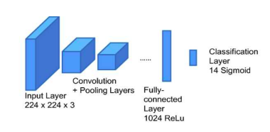

**Fig 1**

**This section describes the CNN model which includes the phases used for covid-19 detection. The phases are shown in Fig. 2 and discussed hereafter.**

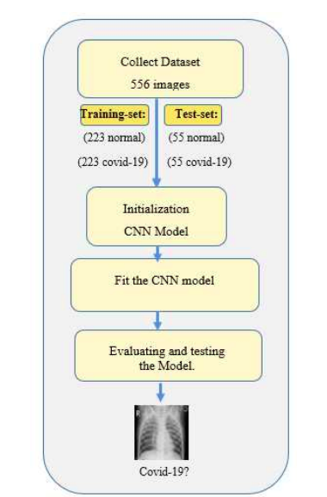

**Fig 2**

***Problem Classification***

**CNN – Convolutional Neural Network is a powerful deep neural network that is widely used in Image Recognition, Image Segmentation, Computer Vision, and many other image-related tasks. The input to these networks is images.**

**The CNNs are inspired by visual system of human brain. The idea behind the CNNs thus is to make the computers capable of viewing the world as humans view it. This way CNNs can be used in the fields of image recognition and analysis, image classification, and natural language processing .**

**CNN is a type of deep neural networks which contain the convolutional, max pooling, and nonlinear activation layers. The convolutional layer, considered as a main layer of a CNN, performs the operation called “convolution” that gives CNN its name. Kernels in the convolutional layer are applied to the layer inputs. All the outputs of the convolutional layers are convolved as a feature map. In this study, the Rectified Linear Unit (ReLU) has** **been used in the activation function with a convolutional layer which is helpful to increase the nonlinearity in input image, as the images are fundamentally nonlinear in nature. Thus, CNN with ReLU in the current scenario is easier and faster.**

**Since the ReLU is zero for all negative inputs, it can be defined as**

**Z = max(0,i)**

**Here, the function implies that the output *z* is zero for all negative value and positive value remains the constant as shown in Fig 3**

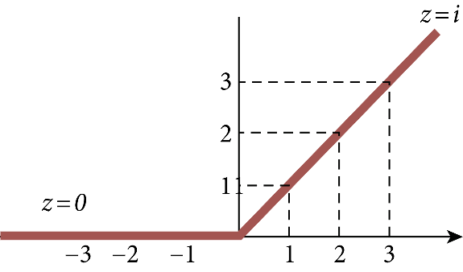

**Fig 3**

**The pooling layer or subsampling layer is also an important building block of CNN. On each feature map extracted through the convolution layer, the pooling layer operates independently.**

**To minimize overfitting and the number of extracted features, it decreases the spatial size of the feature map and returns the important features. Pooling can be the max, average, and sum in the CNN model. In this study, max pooling has been used because others may not identify the sharp features easily as compared to max pooling.**

**In addition, the batch normalization layer has been used in this study as it involved the training of a very deep neural network. So the technique adjusts the scaling and activation to normalize the input layer and speed up the learning procedure between hidden units. The dropout layer with a 20% dropout rate has also been used, which drops the neurons during the training chosen at random to reduce the overfitting problem.**

**Towards the last stage of the CNN used in the study, there is a flatting layer to convert the output of convolutional layers into a single-dimensional feature vector. In other words, the flattening layer arranges all the pixel data output produced by convolutional layers in one vector. After flattening, the vector data is given as an input to the next layers of the CNN called fully connected layers or dense layers. In a fully connected layer, each neuron of the previous layer is directly connected to each of the neurons in its next layer.**

**The main functionality of dense layers is to take flattened output results from the convolution and pooling layers and as input and classify the image to a specific class label. Each value of the flattened feature set represents the probability of a feature belonging to a specific class. Thus, on the basis of these probabilities, the fully connected network with dense layers finally drives the classification decision**.

**XAI – Shortened form of Explainable AI, which contrasts from the traditional black-box nature of the AI models. It is capable of explaining AI solutions, which could be understood by humans.**

**Explainable AI comes to the rescue. It explains and adds meaning to the model. The explainer models can help decode the black-box nature of the AI models.**

**This paper proposes a new explainable convolutional neural network (XCNN) which represents important and driving visual features of stimuli in an end-to-end model architecture. This network employs encoder-decoder neural networks in a CNN architecture to represent regions of interest in an image based on its category. The proposed model is trained without localization labels and generates a heat-map as part of the network architecture without extra post-processing steps. The experimental results on the X_RAY datasets showed the success of our algorithm (XCNN) to make CNNs explainable while offering a simple architecture that can be reapplied to any CNN classifier.**

***Types of Explainability***

**Post-hoc: This is when we explain a model after predictions have been made or after the model has been trained. This is great because these methods allow us to explain highly complicated models. However these methods can be fooled, are flawed under specific conditions and require an extra layer of complexity to generate the explanations. Common examples are the SHAP and LIME Python packages.**

**Inherent: Some models can be explained out of the box, without additional models or libraries laid on top. These are typically simpler and in some cases might have less predictive power — although some researchers argue that this isn’t always the case!**

**LIME – It stands for Local Interpretable Model-Agnostic Explanations. It is an algorithm that can faithfully illustrate the predictions of the AI models by approximating them locally using an explainer model that can be interpreted**

**LIME also employs a Ridge Regression model on the samples using only the obtained features. The outputted prediction should theoretically be similar in magnitude to the one outputted by the original prediction model. This is done to stress the relevance and importance of these obtained features.**

***Implementation***

**The proposed CNN model consists of 5 layers in which 4 are convolutional (Conv2D), 4 max pooling2D layers, 4 dropout layers, 6 activation function layers, 1 flatten layer, and 1 fully connected layers; CNN model input image shape is (224, 224, 3), i.e., 224-by-224RGB image. In all Con2D layers, a 3 × 3 size kernel has been used but the filter size after every two Con2D layers increases. At the 1st layers of Con2D, 64 filters have been used to learn from input and 2nd layers of Con2D,128 filters and the 3rd layers of Con2D use 256 filters, and at the 4th layers, 512 filters have been used. After each Con2D layer, the max pool2D layer with 2 × 2 pooling size has been used, the activation layer has been used with the ReLU function, and the dropout layer has been used with 20% dropout rate in 2nd , 3rd , 4rd . The output of 256 output neurons of the final Con2D layer is followed by max pool2D, activation, and dropout layer. Since the final pooling and convolutional layer gives a three-dimensional matrix as output, to flatten the matrix, a flattening layer has been used which converts them into a vector that will be input for 2 dense layers fully connected flattening layer has been used which converts them into a vector that will be input for 2 dense layers fully connected and Fig4 explain that.**

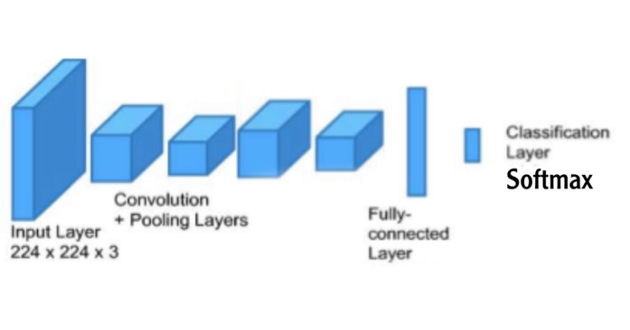

**Fig 4**

This section describes the CNN model which includes the phases used for covid-19 detection. The phases are shown in Fig 5 and discussed hereafter.

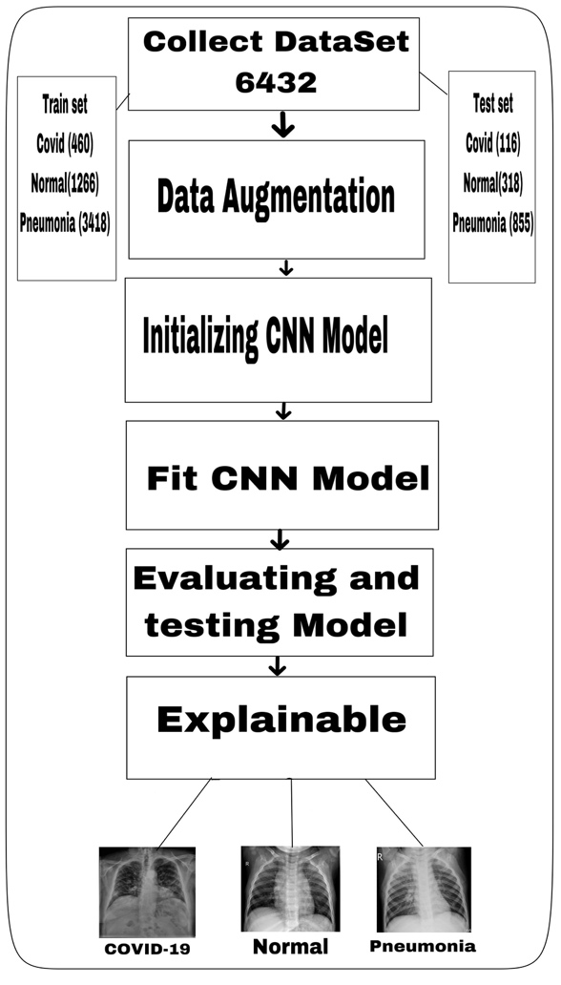

**Fig 5**

* ***Data set***

**The dataset to perform the diagnosis and explainable requires X-Ray images from Covid-19 affected, normal and Pneumonia affected patients. So, the images have been collected from Kaggle and were combined together, for this project.**

**The data set divided into two classes every class has three categories (Covid-19, Normal, Pneumonia).**

**The whole data set consists of 6432 this data divided into train set and test set.**

**The train set consists of 5144 Xray separated to 460 Covid 19 ,1266 Normal and 3418 Pneumonia.**

**The test set consists of 1288 Xray separated to 116 Covid 19, 318 Normal, 855 Pneumonia.**

**Results are shown in Fig 6**

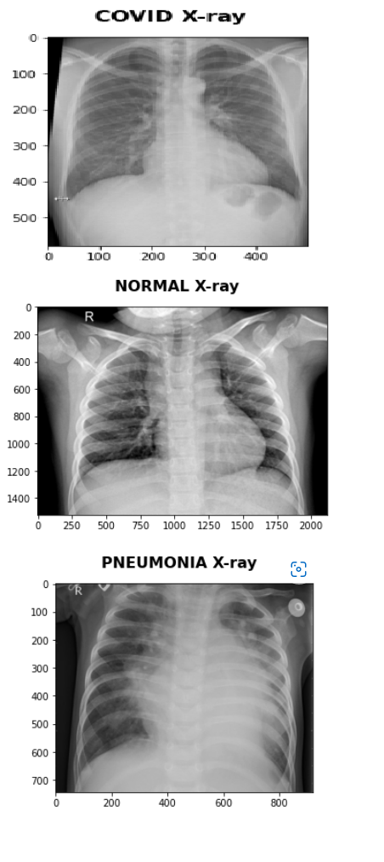

**Fig6**

* ***Data Augmentation***

**Data augmentation is a set of techniques to artificially increase the amount of data by generating new data points from existing data. This includes making small changes to data or using deep learning models to generate new data poin**

**For data augmentation, making simple alterations on visual data is popular. Classic image processing activities for data augmentation are:**

1. **padding**
2. **random rotating**
3. **re-scaling,**
4. **vertical and horizontal flipping**
5. **translation (image is moved along X, Y direction)**
6. **cropping**
7. **zooming**
8. **darkening & brightening/color modification**
9. **gray scaling**
10. **changing contrast**
11. **adding noise**
12. **random erasing**

**Data Augmentation in Keras is supported by the “ImageDataGenerator” class. It is applied to improve the model’s ability to generalize. A rescale parameter has been used to multiply every pixel in the image. It is transforming every pixel value from [0, 255] to [0, 1] to treat all the images in the same manner and also to have a large learning rate.**

**Generate Training Data**

**The training data is prepared by reading the images directly from the directory and creating batches, train_generator, and validation generator. This is done to identify the classes automatically from the folder name. Here the images are being reshaped into an input size of 224 X 224 and the batch size has been fixed to 16.**

* ***Initializing CNN Model***

**CNN has been used to train the model on the prepared dataset so that the model can predict whether the X-Ray image**

**It is a Sequential model with five convolutional layers. To ensure that more feature learning happens, the filters in each convolutional layer have been increased gradually. The lower layers are capable of detecting the features on the smaller part of the image. And as we move deeper into the layers of the neural network, the receptive nature of the layers increases. The input shape in the first hidden layer is specified to 224 X 224 pixels with three channels.**

**The convolutional layers are followed by the Max Pooling layers, which discards all such features that do not contribute towards the final prediction made. The network also has Dropout layers. The addition of these extra layers prevents the neural network from overfitting.**

**The activation function used is relu, as it overcomes the vanishing gradient problem. A Flatten layer is added before the Dense layers, to convert the data into a one-dimensional array. The softmax activation has been used for the output layer of the network because it is a categorical classification problem.**

**Now, we need to compile the model, and for this, we have used categorical_crossentropy as the loss function, adam as the optimizer and accuracy has been used as the metric to evaluate the model performance..**

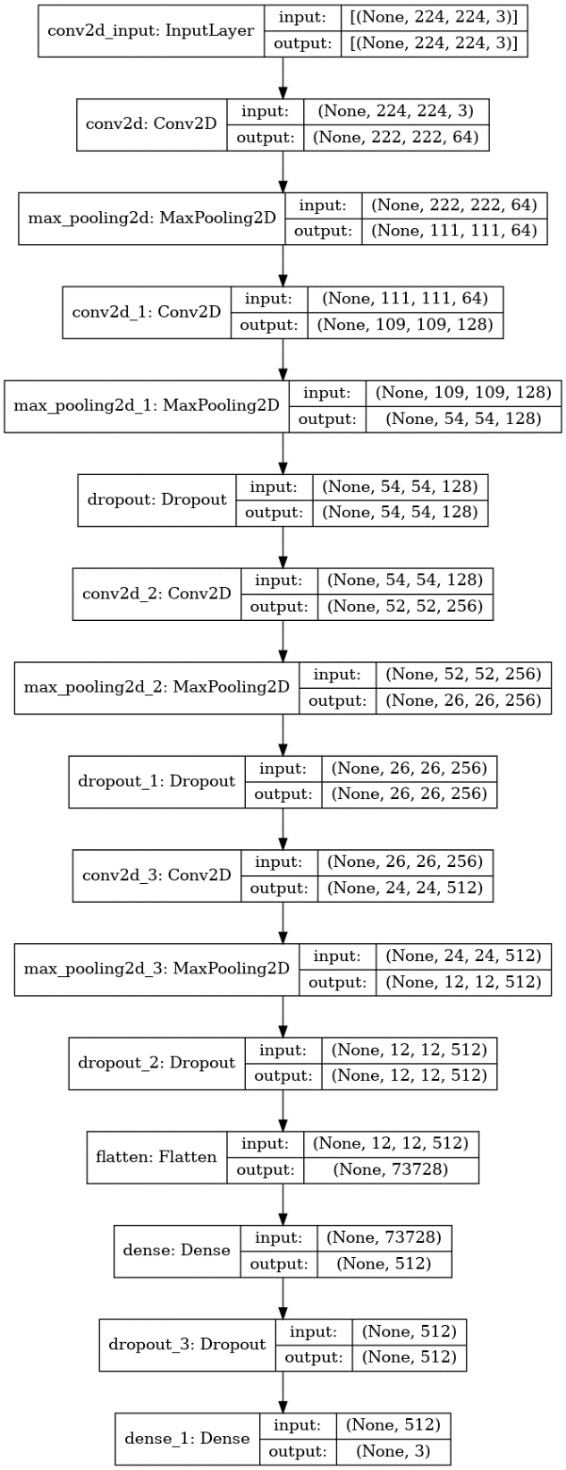

**Fig 7**

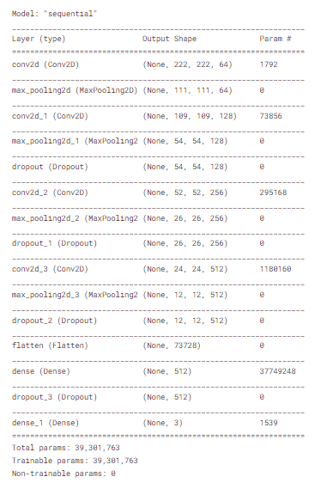

**Fig 8**

* ***Fit CNN Model***

**model fit using training_set, test_set, steps_per_epoch are128 and epochs are 111**

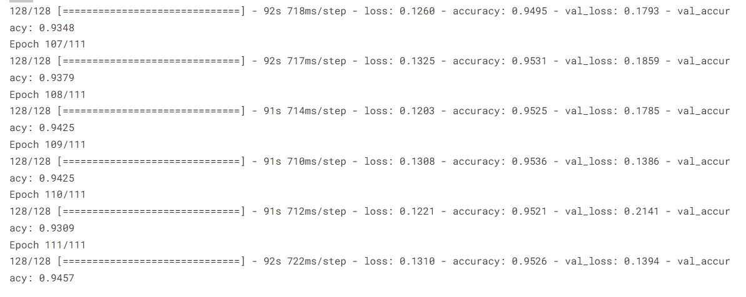

**Fig 9**

* **Evaluating and Testing Model**

**The next step is to measure the model performance. As the evaluation metric used in model.compile is accuracy, the evaluate_generator evaluates the model performance on it. The training set has resulted in a loss of 0.13 and an accuracy of 95.26%. Whereas, the validation set gave a loss of 0.13 and an accuracy of 94.56%. As the difference between the training and the validation loss it is a good sign that our model is not overfitting.**

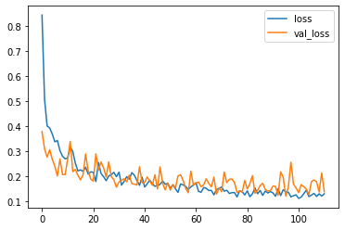

**Fig 10**

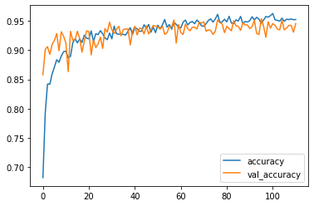

**Fig 11**

**So, looking into the figure above, we can say that the training and the validation loss is decreasing with an increase in epoch and the accuracy for both the set is increasing, with an increase in the epoch**

**Confusion Matrix for X_ray Detection usingCNN with actual data**

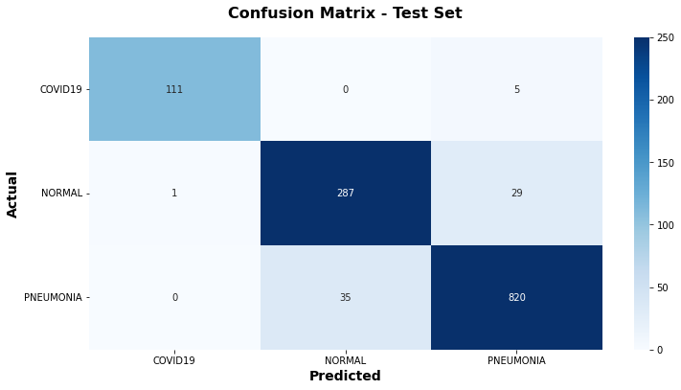

**Fig 12**

**Precision is the degree to which estimates from different samples are similar. The standard error, for example, is a precision metric. When the standard error is modest, estimates from different samples will be near in value; conversely, when the standard error is large, estimates from different samples will be far apart in value. Precision = True Positive/(True Positive + False Positive)**

**Recall by identifying it as Positive, Recall estimates how many of the Actual Positives our model captures (True Positive). With the same reasoning, we know that when False Negative has a large cost, Recall will be the model metric we use to choose our best model. Recall= True Positive/(True Positive + False Negative)**

**F1 Score? Depending on the problem you’re trying to solve, you could assign a higher priority to maximize precision or recall in most cases. However, there is a simpler statistic that takes both precision and recall into consideration, and you can seek to maximize this number to improve your model. The F1-score is a statistic that is essentially the harmonic mean of precision and recall. The formula of the F1 score depends completely upon precision and recall. F1 Score= (2*Precision*Recall)/(Precision + Recall)**

**Being the two (Precision,Recall) most important mode evaluation metrics, precision and recall are widely used in statistics. While precision refers to the percentage of relevant results that CNN algorithm successfully classifies, recall refers to the proportion of total relevant results that your algorithm successfully classifies. Unfortunately, maximizing both of these parameters at the same time is impossible, as one comes at the expense of the other.**

Bottom of Form

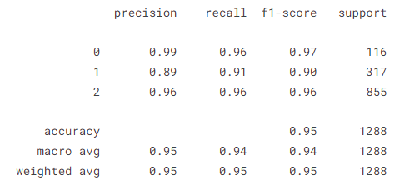

**Fig 13**

* ***Explainable (LIME)***

**LIME helps in understanding the decisions, subsequently made by a black-box model**

**Create an Explainer Object**

**In addition, we need to create an explainer object using the LimeImageExplainer() function. .**

**At first, it generates neighborhood data by perturbing features from the instance, at random. Then, the local weighted linear models on the neighborhood data are used to explain different classes. The parameter top_labels is the number of labels that we want our explainer object to show. For our model, its value is 5**

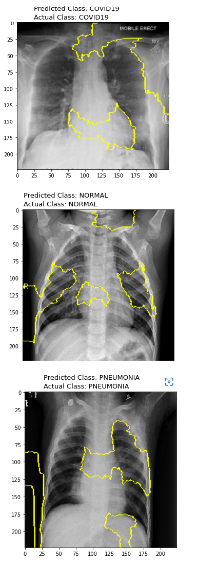

* ***The Web Page***

**We created this page to make the access to our model more easier and faster to have this service globally and we will explain how it works and how we did relate this page with our model in details .**

**First of all we import the libraries that we will use in this project .**

**The libraries that we used are :-**

**1- Flask**

**2- Pillow**

**3- Numpy**

**4- Tensor Flow and Keras**

**These libraries we used them to generate our model and we will see in the next Fig**

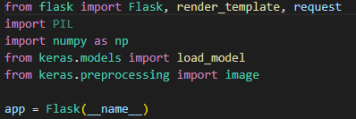

**Fig 14**

**After this we uploaded our model after making its path h5 so we can easily fit it into our model and define that if it’s Covid it’s 0 , Normal it’s 1 and Pneumonia 2 .**

**And then we defined the prediction label to take the image path and resize it to fit the model that we uploaded and the shape was (224,224) as we done in the main model .**

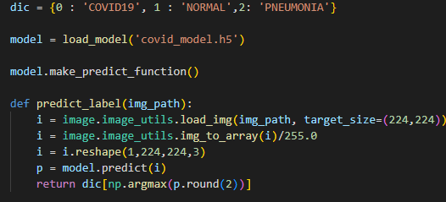

**Fig 15**

**And by Flask we made the routes that will be in the main page and we named them the index and the next page is test and then we route the image into the prediction process then we return the out put as we said earlier if it is Covid , Pneumonia or Normal**

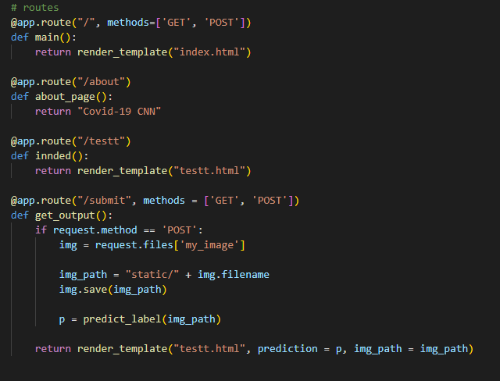

**Fig 16**

**And after we have done the front end of the web page we run the model and it gives us the path that if we click on it , it takes us to the web page that we made .**

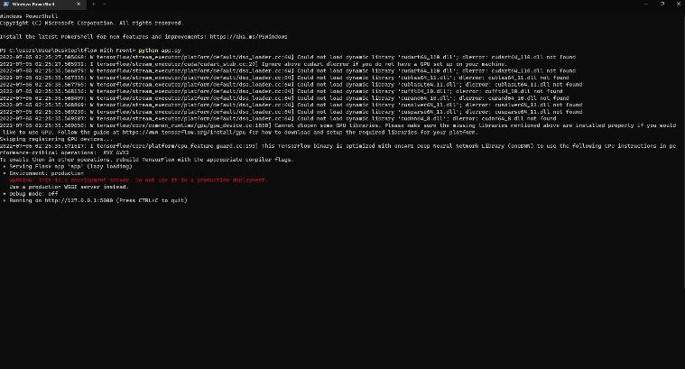

**Fig 17**

**And after all of this the final result of our work is this web page and this is the index page**



**Fig 18**

**And this is the detection page**



**Fig 19**

**After this the user input his X-Ray and the web site predict his diagnoses correctly**



**Fig 20**

**This case is normal .**



**Fig 21**

**And this case is Covid-19 .**



**Fig 22**

**And the final case is Pneumonia .**

* ***IOS Application***

**Another technology we used in this project to make the usage of the model more easier there is no one who don’t have a mobile then we create this app with a connection with the model.**

**Home page**

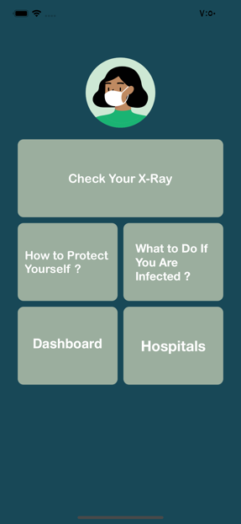

**Fig 23**

**If we press to button “Check Your X-Ray “it will navigate you to the model throw the web Page**



**Fig 24**

**The image picker get the Xray from the gallery and send it to the model and get the prediction**



**Fig 25**

**After this the user input his X-Ray and the app predict his diagnoses correctly**

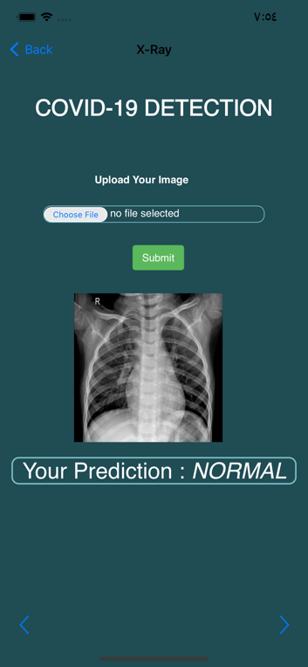

**Fig 26**

**This case is normal .**

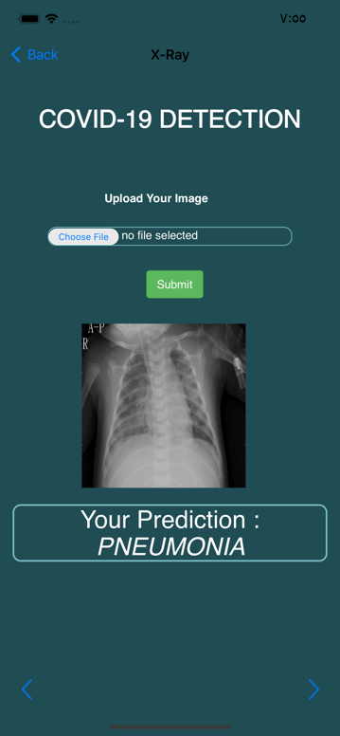

**Fig 27**

**And the final case is Pneumonia .**

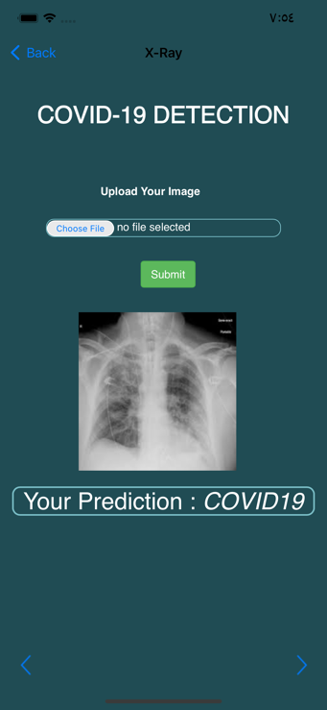

**Fig 28**

**And this case is Covid-19 .**

**if you are infected you should follow these steps to get well**

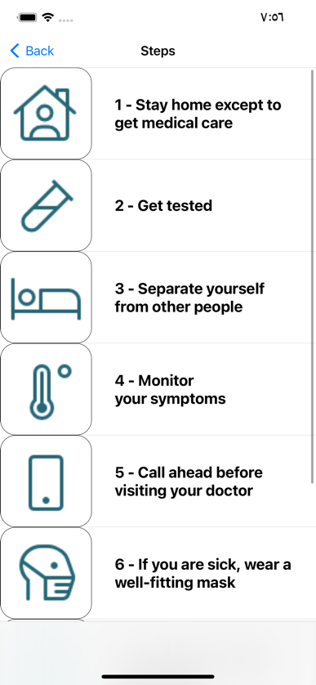

**Fig 29**

**To protect yourself and others you should follow these steps**

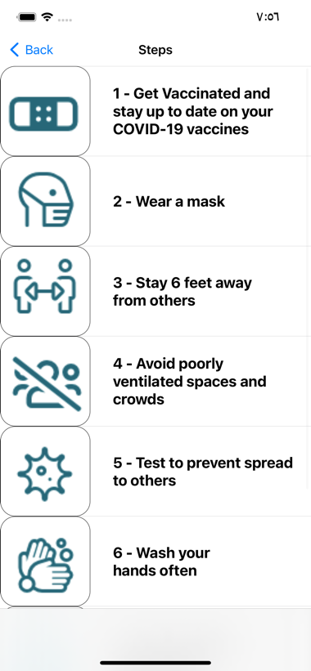

**Fig 30**

**To find the nearest chest hospital to you you will find all chest hospital in Egypt here**



**Fig 31**

**For more information about covid 19 check WHO Coronavirus (COVID-19) Dashboard from dashboard button**

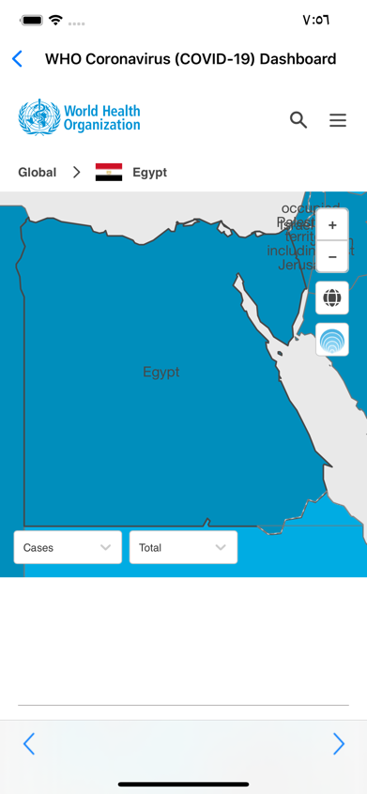

**Fig 32**

* ***Conclusion***

**This project has been conducted to demonstrate the effective and accurate diagnosis of COVID-19 using CNN which was trained on chest X-ray image datasets. The model training was performed incrementally with different datasets to attain the maximum accuracy and performance. The primary dataset was very limited in size and also imbalanced in terms of class distribution. These two issues with the primary dataset affected the performance of the models very badly. To balance the dataset for model training and also to test its performance parameters, an ample number of chest X-rays were collected from different available sources. After training and testing the CNN model on the fully processed dataset, the performance results have been reported.**

**Since this study uses an incremental approach in training the model using different sizes and types of datasets, the approach confirmed the fact that CNN models require an ample amount of image data for the efficient and more-accurate classification.**

* ***References***

1. **Covid using CNN By Ahmad Saber**

**Via:** [**https://www.kaggle.com/code/ahmedsaberelsheikh/covid19-using-cnn**](https://www.kaggle.com/code/ahmedsaberelsheikh/covid19-using-cnn)

1. **D. Cucinotta and M. Vanelli, “WHO declares COVID-19 a pandemic,” *Acta Biomedica: Atenei Parmensis*, vol. 91, pp. 157–160, 2020**.

**Via :** [**https://www.ncbi.nlm.nih.gov/pmc/articles/PMC7569573/**](https://www.ncbi.nlm.nih.gov/pmc/articles/PMC7569573/)

1. **F. Rustam, A. A. Reshi, A. Mehmood et al., “COVID-19 future forecasting using supervised machine learning models,” *IEEE Access*, 2020**.

**Via :** [**https://ieeexplore.ieee.org/abstract/document/9099302**](https://ieeexplore.ieee.org/abstract/document/9099302)

1. **Hammoudi K., Benhabiles H., Melkemi M., Dornaika F., Arganda-Carreras I., Collard D., Scherpereel A. (2020) Deep learning on chest x-ray images to detect and evaluate pneumonia cases at the era of covid-19**

**Via :** <https://arxiv.org/abs/2004.03399>

1. **Coronavirus and Pneumonia**

**Via :** [**https://www.webmd.com/lung/covid-and-pneumonia#1**](https://www.webmd.com/lung/covid-and-pneumonia#1)

1. **Immunopathogenesis of Pneumonia in COVID-19**

**Via :** [**https://www.ncbi.nlm.nih.gov/pmc/articles/PMC7680509/**](https://www.ncbi.nlm.nih.gov/pmc/articles/PMC7680509/)